Title of Paper

Author Name ^{1*}, Author Name ², ···, Author Name ²

¹ First author’s affiliation, address
² Second author’s affiliation, address
*Corresponding author: e-mail address

Use of the template is mandatory [1]. A maximum size of two pages is required for all papers (invited and contributed).
Abstracts must be submitted prior to July 15, 2019 for oral presentation, Sep 15, 2019 for poster presentation. The presenting author must be a paid registrant. All abstracts (both MS word and it’s PDF files) should be sent to icms2019@hmfl.ac.cn, by e-mail. Please include your name in subject line and folder name, as well as your oral or poster preference.
Text, mathematical expressions, graphs, tables, and figures are allowed. The text must be typed with Times New Roman. The text should contain the following items in the exact given order and written in English:
1) Title of the paper: 14 pt size font, use bold.
2) Author (initials or first names before surnames, 12 pt size font), separated by commas and each followed by a footnote letter (1, 2, 3, ...) referring to the respective address (11 pt size font). Please draw under line for the presenting person.
3) Addresses, each preceded by a footnote letter referring to the respective author name (s) (11 pt size font).
4) Main Text preferably should not be partioned into sections (11 pt size font).
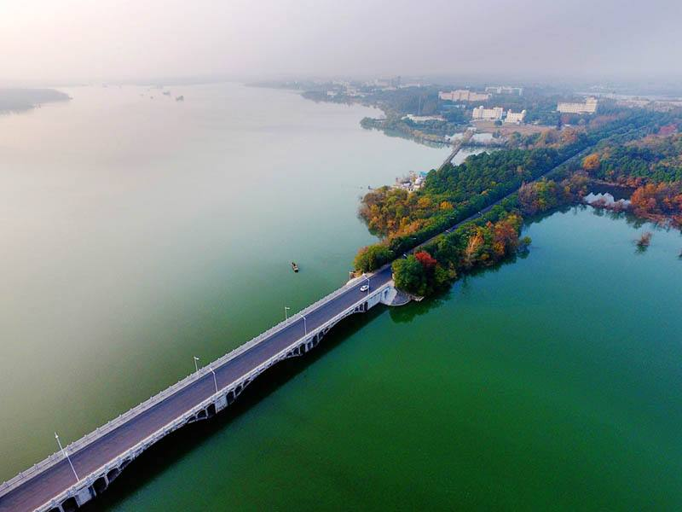
Fig. 1 Science island is a beautiful place.
5) References should be limited to the most relevant literature. They should all be cited in the text, numbered in square brackets consecutively in order of first appearance.
6) Figures must be sufficiently large in order for all details not to become illegible in printed form. Figure captions shoule be 11 pt size font.
7) Page limit for each abstract is two printed pages.

Authors are asked to follow as close as possible the template provided. (Use of MS-Word is strongly recommended.)

[1] A. Bcc, D. E. Fgg, and H. Ijj, Name of the Journal 4 (2017) 1-5.

